(Approx. 1,186 words)

On the 7th Day of Christmas, My True-Geek Gave to Me
By Lou Torraca, President, The TUG MOAA Computer User Group, Hawaii
www.the-tug.org
af06hi (at) gmail.com

This article has been obtained from APCUG with the author’s permission for publication by APCUG member groups; all other uses require the permission of the author (see e-mail address above).
Greetings shoppers…last minute or as one of my readers pointed out, just closer to THE DAY than your Nov shoppers! As promised, I have listed the 7th through 12th days and their gifts for your shopping fun…remember my standard advice…surf the web and compare. And...if u haven't yet signed up at the top right side of the page, please do and give me your rating. To encourage you to “just do it”…I have not listed URLs, but when you signup, do a rating and email me, I will be glad to tell you what it is…Signup is easy and safe. {:-)
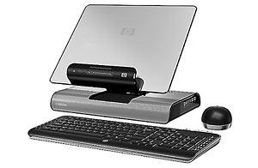
To begin, for the 7th day a really handy Notebook Docking Station, read what they say and I think you’ll agree.
Use your laptop screen as your monitor, and position it at the perfect viewing height. Save space on your desk and use a single connection for power, peripherals, and the Web. What makes it all possible: our xb4 Notebook Media Docking Station, which includes a full-sized wireless keyboard and wireless optical mouse.
- Adjust your notebook to the best viewing height
- Stay connected to everything—power1, peripherals, Internet—via a single cable
- Get excellent sound with the powerful, integrated Altec Lansing 2.1 speaker system
- Connect an MP3 or CD player to the docking station's auxiliary audio-in port
- Back up data on the integrated HP Media Drive storage bay—just connect our Personal Media Drive2 or Pocket Media Drive3 directly to the docking station
- Connect a secondary notebook via USB, then share USB peripherals connected to your docking station4
- Charge USB devices even when your notebook is disconnected; the docking station supplies six powered USB ports
- Use the ports: VGA for connecting an external monitor, Ethernet, multiple audio outputs, microphone, and consumer IR for a mobile remote control (sold separately)
- Plug and play: you need no drivers or software for setup
- Get answers to product questions toll-free, 24 x 7, or via e-mail in as little time as an hour
- Warranty: one-year limited
- Compatibility: HP Pavilion dv4, dv5, dv6, dv7, dv2000, dv6000, dv9000, tx2, tx1000, tx2000 series; HP HDX 16, 18 series; Compaq Presario CQ45, V3000, V6000 series
- Notes:
• 1. AC adapter sold separately.
• 2. Sold separately.
• 3. Sold separately; requires HP Pocket Media Drive Adapter Kit (also sold separately).
• 4. Only one notebook can access the docking station's USB ports and optional storage options at a time; actual product may vary from image shown on datasheet.
For the 8th day: I can think of a number of people who need one of these…can’t you?
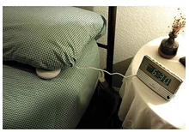
If a Sonic Boom alarm clock can't wake you up, you're probably asleep for good! In addition to extra-loud beepers, their startling bed-quaking vibrators will rattle you out of any slumber. Variable tone and volume controls let you set the most effective alarm. Position the bed vibrator under the mattress or a pillow and it will pound the bed when it's time to wake up! Includes AC adapter.

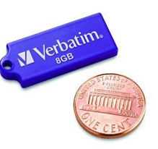
Day 9: Back to serious geek-ness, Verbatim has just what you need with their latest thumb drives in 2, 4 and 8GB flavors. Actually the 8GB one was renamed by a friendly wag as a pinkie drive…see the pic and you’ll probably agree!
Features & Benefits
- Tiny, rugged USB drive measures 1.19 x 0.5 x 0.06 inch
- Resistant to dust, water and static discharges
- Compatible with ALL USB ports
- Password security for Windows users
- Enhanced for Windows® ReadyBoost™
- Compatible with Windows 7, Vista, XP or 2000, Mac OS 9.x or higher, Linux kernel 2.6x or higher
- Bonus key ring lanyard for mobile phones or key rings
OR:
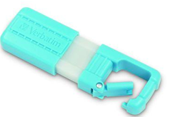
TUFF-CLIP™ 4GB USB Drive - Turquoise
Looking for a portable USB drive that’s tough enough for backpacks or key rings? Check out the new Verbatim TUFF-CLIP™ USB Drive. This rugged flash drive clips onto backpacks, belt loops or even notebooks. With an easy slider that protects the USB connector, the TUFF-CLIP™ USB drive is super durable and great for music, videos, school projects or photos. It also offers a password security feature that ensures you’re the only one who can access your important information. This drive is enhanced for Windows® ReadyBoost™ for Windows 7 and Vista users. With the Verbatim TUFF-CLIP™ USB drive, just clip and carry your files with you! I know, it’s so hard to make a choice…colors, capacity…so go on and get one of each, that’s the easy way.
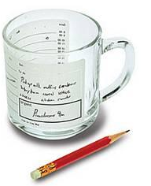
Day 10: Would you believe a coffee mug you can take notes on!!
"Can I take a message? Hang on, just gotta grab something to write on... okay, this mug will do!" Yeah, that's write, er, right, you can write on this mug! Take notes, jot down your meeting schedule, make to-do lists and hydrate yourself, all with the same cup. Just wash it to erase it. Includes a pencil and a printed reminder to take a coffee break at 3:45.
Day 11: A messenger bag that comfortably carries way more than a bag of its size normally could! It's big enough to carry a 17" laptop, Large 3-ring binder, two college textbooks, two paperback books, Amazon Kindle, iPod, cellphone, cables, pencils, business cards, spare batteries... I could go on and on.
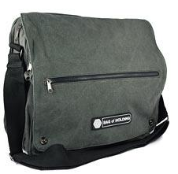
Features
- Main padded laptop compartment big enough to hold a 17" laptop
- Interior pocket dimensions:
- Main Padded Laptop Compartment: 16" x 13.5" x 3"
- Huge second compartment: 16" x 13.5" x 3"
- Third compartment: 13" x 10" x 1"
- Fourth velcro compartment: 12" x 7" x 1"
- Front zipper pocket: 13" x 5"
- Rear Document pocket: 16" x 10"
- Sturdy canvas, brass zippers and pop-rivet construction
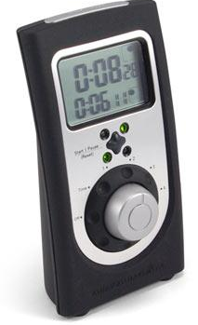
And finally for your favorite chef-geek, on Day 12:
Geek Cuisine
Mad Scientists, Potions Masters, and Head Chefs all have one thing in common: they have to make sure things happen at the right time. Attach a neck bolt, add a pinch of dried wormwood, or over-fry the sliced potatoes, and everything could be ruined. The Chef’s Quad-Timer line is designed for the serious home chef, the avid entertainer, and the modern multi-tasker. Designed to compliment today’s upscale home kitchens, dungeons, and laboratories, this unique product features an eye-catching form and progressive functionality.
The Chef’s Quad-Timer makes multi-tasking easy. It features an intuitive cook top metaphor: the four colored lamps on the face of the timer visually connect what’s being timed with what’s on the stove. Running timers illuminate in green and flash red when expired. And the Chef’s Quad-Timer is easy to use. All settings are quickly adjusted using the rotary dial.
Have a very Merry Christmas and enjoy your shopping. See yah next year.
Aloha,
LOU

